**Practical No. 5**

**AIM:-** Introduction to R programming and Data acquisition.

**Objective: -** To understand the concept of R Programming. and evaluate different data mining techniques like classification, prediction, clustering and association rule mining in R

**R Commands:-**

myString <- "Hello, World!"

print ( myString)



#setwd() - sets working directory.

setwd("D:/58")

getwd() ##getwd() - gets current

working directory.



dir() ## dir() - lists the contents of current working directory.



ls() ##ls() - lists names of objects in R environment

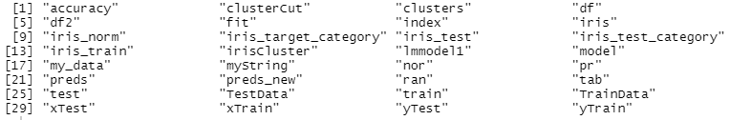

#Creating and assigning to a variable:

x<-1

class(x)



#Printing a variable:

#auto-printing

print(x) #explicit printing



x<-'c'

is.character(x) #check if character



is.integer(x) #check if integer



y<-'2.14'

as.integer(y)



###Creating Vector: contains objects of same class.

y<-vector("logical",length=10)

length(x)



y<-c(4,5,6)

5*x



###Creating Matrix: Two-dimensional array having elements of same class.

m<-matrix(c(11,12,13,55,60,65,66,72,78), nrow=3,ncol=3)

m

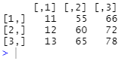

dim(m)



attributes(m)



matrix(c(11,12,13,55,60,65,66,72,78),nrow=3,ncol=3,byrow = TRUE)

m

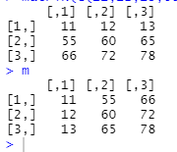

x<-c(1,2,3) y<-c(11,12,13)

cbind(x,y)

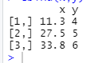

rbind(x,y)



p<-3*m

p

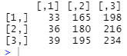

n<-matrix(c(4,5,6,14,15,16,24,25,26),nrow=3,ncol=3)

q<- m+n

q

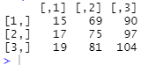

o<-matrix(c(4,5,6,14,15,16),nrow=3,ncol=2)

o

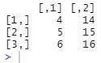

r<-m%*% o

r

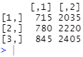

mdash<-t(m)

mdash

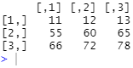

s<-matrix(c(4,5,6,14,15,16,24,25,26), nrow=3,ncol=3,byrow=TRUE)

s_det<-det(s)

s_det



###List: A special type of vector containing elements of different classes. ####Elements of list can be accessed by giving

element index or name in [[]].

x<-list(1,"p",TRUE,2+4i)

x

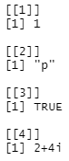

###Factor: Represents categorical data. Can be ordered or unordered.

status<-c("low","high","medium","high","low")

x<-factor(status, ordered=TRUE,levels=c("low","medium","high"))

x



###Data frame: Used to store tabular data. Can contain different classes.

student_id<-c(1,2,3)

student_names<-c("Ram","Shyam","Laxman")

position<-

c("First","Second","Third")

data<-data.frame(student_id,student_names,position)

data

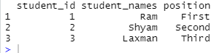

data$student_id



nrow(data)



ncol(data)



names(data)



smoke <- matrix(c(51,43,22,92,28,21,68,22,9),ncol=3,byrow=TRUE)

colnames(smoke) <- c("High","Low","Middle")

rownames(smoke) <-

c("current","former","never")

smoke <- as.table(smoke)

smoke

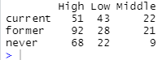

Reading and writing data from csv

dataT <- read.table("na_data.csv", sep =",", header = T)

dataT

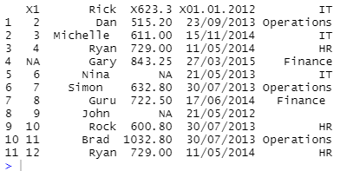

dim(dataT)



head(dataT, 2)



tail(dataT, 2)



z <- data.frame(a = 5, b = 10, c = pi)

write.csv(z,file="data.csv")

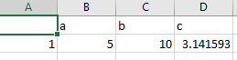

Reading and writing data from Excel using XLConnect

dataX <- XLConnect:: readWorksheetFromFile("employee_info.xls",sheet=1)

dataX

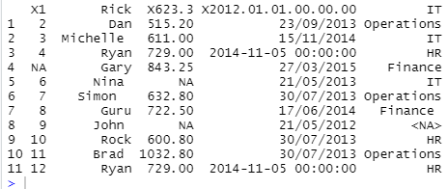

dataY<- dataX[1:2,]

dataY



Reading and writing data from Excel using readXL and writeXL

data <-data.frame(Name=character(), Age=numeric())